Open Transaction prompted “Requested objects cannot be loaded, because they are absent in the data store. These objects can already be deleted/purged.”
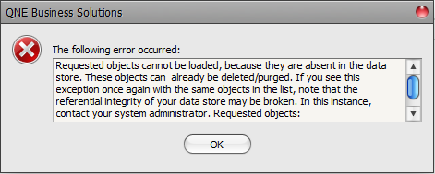
Solution:
- Go to Stocks > Stock Items > Search
- Select Edit and click ‘Scan UOM’
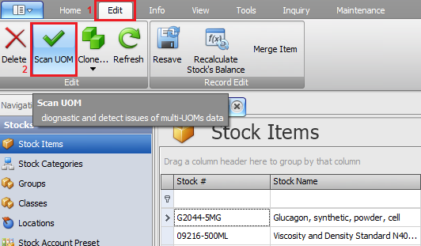

- On the result, take note / mark down of those Stock Code that missing UOM.
- Click Auto Fix
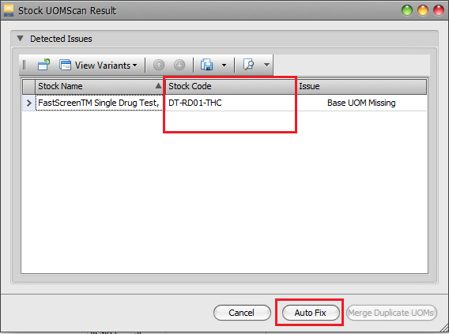
- Obtain script from Appendix 1 or below link
https://drive.google.com/open?id=0BzrrsMUq-H6gRFpfTDZaYmE4czA
- Replace STOCK-001 with the Stock Code that missing UOM
update QuotationDetails
set uomid= (select id from uoms where stockid=(select id from stocks where
stockcode='STOCK-001'))--Replace STOCK-001 with the Stock Code that missing UOM--
where stockid in (select id from stocks where
stockcode = ('STOCK-001'))--Replace STOCK-001 with the Stock Code that missing UOM—
CHANGE TO >>
update QuotationDetails
set uomid= (select id from uoms where stockid=(select id from stocks where
stockcode='DT-RD001-THC'))--Replace STOCK-001 with the Stock Code that missing UOM--
where stockid in (select id from stocks where
stockcode = ('DT-RD001-THC'))--Replace STOCK-001 with the Stock Code that missing UOM--

- Repeat step No. 6 if more than 1 Stock’s UOM missing.

Appendix 1 (https://drive.google.com/open?id=0BzrrsMUq-H6gRFpfTDZaYmE4czA)
update QuotationDetails
set uomid= (select id from uoms where stockid=(select id from stocks where stockcode='STOCK-001'))--Replace STOCK-001 with the Stock Code that missing UOM--
where stockid in (select id from stocks where stockcode = ('STOCK-001'))--Replace STOCK-001 with the Stock Code that missing UOM--
-----
update SalesOrderDetails
set uomid= (select id from uoms where stockid=(select id from stocks where stockcode='STOCK-001'))--Replace STOCK-001 with the Stock Code that missing UOM--
where stockid in (select id from stocks where stockcode = ('STOCK-001'))--Replace STOCK-001 with the Stock Code that missing UOM--
-----
update DeliveryOrderDetails
set uomid= (select id from uoms where stockid=(select id from stocks where stockcode='STOCK-001'))--Replace STOCK-001 with the Stock Code that missing UOM--
where stockid in (select id from stocks where stockcode = ('STOCK-001'))--Replace STOCK-001 with the Stock Code that missing UOM--
-----
update SalesInvoiceDetails
set uomid= (select id from uoms where stockid=(select id from stocks where stockcode='STOCK-001'))--Replace STOCK-001 with the Stock Code that missing UOM--
where stockid in (select id from stocks where stockcode = ('STOCK-001'))--Replace STOCK-001 with the Stock Code that missing UOM--
-----
update SalesDNDetails
set uomid= (select id from uoms where stockid=(select id from stocks where stockcode='STOCK-001'))--Replace STOCK-001 with the Stock Code that missing UOM--
where stockid in (select id from stocks where stockcode = ('STOCK-001'))--Replace STOCK-001 with the Stock Code that missing UOM--
-----
update SalesCNDetails
set uomid= (select id from uoms where stockid=(select id from stocks where stockcode='STOCK-001'))--Replace STOCK-001 with the Stock Code that missing UOM--
where stockid in (select id from stocks where stockcode = ('STOCK-001'))--Replace STOCK-001 with the Stock Code that missing UOM--
-----
update CashSalesDetails
set uomid= (select id from uoms where stockid=(select id from stocks where stockcode='STOCK-001'))--Replace STOCK-001 with the Stock Code that missing UOM--
where stockid in (select id from stocks where stockcode = ('STOCK-001'))--Replace STOCK-001 with the Stock Code that missing UOM--
-----
update PurchaseRequisitionDetails
set uomid= (select id from uoms where stockid=(select id from stocks where stockcode='STOCK-001'))--Replace STOCK-001 with the Stock Code that missing UOM--
where stockid in (select id from stocks where stockcode = ('STOCK-001'))--Replace STOCK-001 with the Stock Code that missing UOM--
-----
update PurchaseOrderDetails
set uomid= (select id from uoms where stockid=(select id from stocks where stockcode='STOCK-001'))--Replace STOCK-001 with the Stock Code that missing UOM--
where stockid in (select id from stocks where stockcode = ('STOCK-001'))--Replace STOCK-001 with the Stock Code that missing UOM--
-----
update GoodsReceivedNoteDetails
set uomid= (select id from uoms where stockid=(select id from stocks where stockcode='STOCK-001'))--Replace STOCK-001 with the Stock Code that missing UOM--
where stockid in (select id from stocks where stockcode = ('STOCK-001'))--Replace STOCK-001 with the Stock Code that missing UOM--
-----
update PurchaseInvoiceDetails
set uomid= (select id from uoms where stockid=(select id from stocks where stockcode='STOCK-001'))--Replace STOCK-001 with the Stock Code that missing UOM--
where stockid in (select id from stocks where stockcode = ('STOCK-001'))--Replace STOCK-001 with the Stock Code that missing UOM--
-----
update PurchaseDNDetails
set uomid= (select id from uoms where stockid=(select id from stocks where stockcode='STOCK-001'))--Replace STOCK-001 with the Stock Code that missing UOM--
where stockid in (select id from stocks where stockcode = ('STOCK-001'))--Replace STOCK-001 with the Stock Code that missing UOM--
-----
update PurchaseReturnDetails
set uomid= (select id from uoms where stockid=(select id from stocks where stockcode='STOCK-001'))--Replace STOCK-001 with the Stock Code that missing UOM--
where stockid in (select id from stocks where stockcode = ('STOCK-001'))--Replace STOCK-001 with the Stock Code that missing UOM--

