How to Update Tax Amount into Landing Cost
The Scenario is User want to put Tax amount as landing cost in stock, thus we actually able to create in customization centre and put the calculation into the landing cost.
In this case, we create a landing cost and named it as Cost A.
- Go to Purchases > Landing Costs > Tick Enable cost > put the name as Cost A.
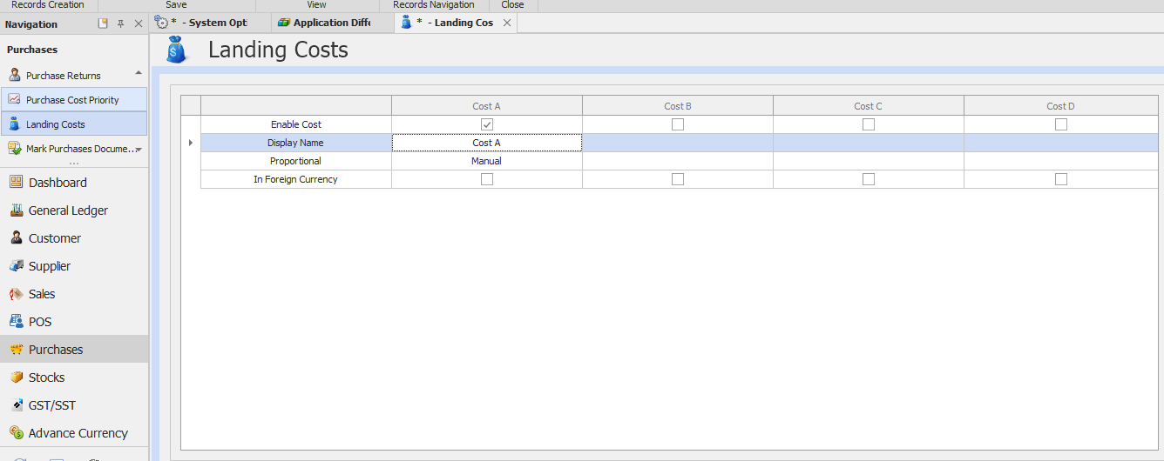
- Go to Customization Centre > Double click on QNE Optimum
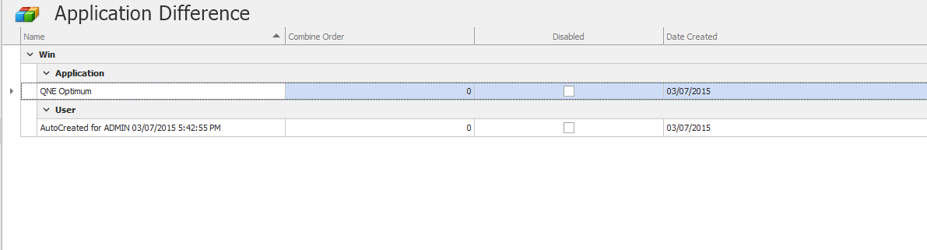

- For example, we create in Purchase Order. So in the Customization Center,
Go to BOModel > QnEBO.BS.Purchases > PurchaseOrderDetails > EvaluateExpressions > Right click > Add > MemberEvaluateExpression
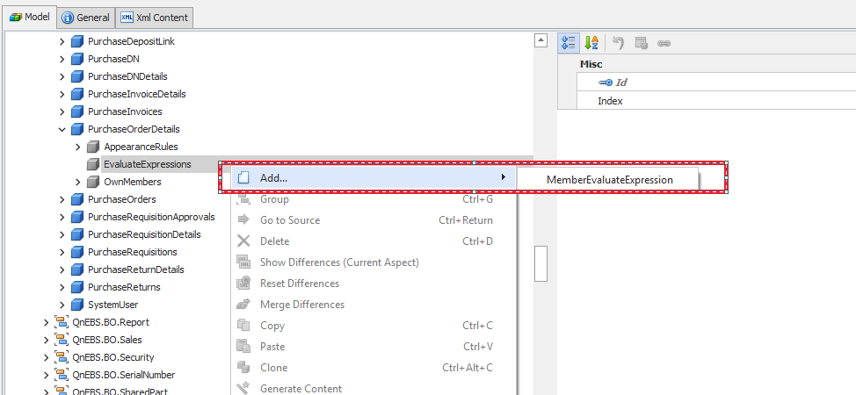
- Then create an evaluate expression by setting the Amount* TaxRate
This is to add the calculation into the landing cost. Because we want to add in the tax amount into their costing.
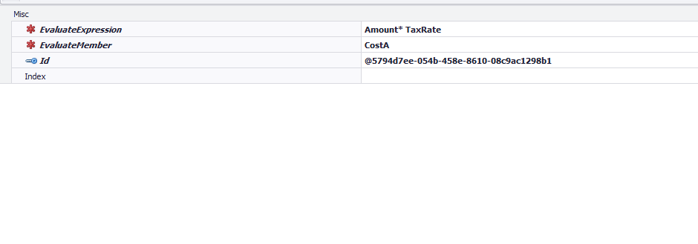

- When we key in the PO. Result will be like this. It will automatically post to the CostA.
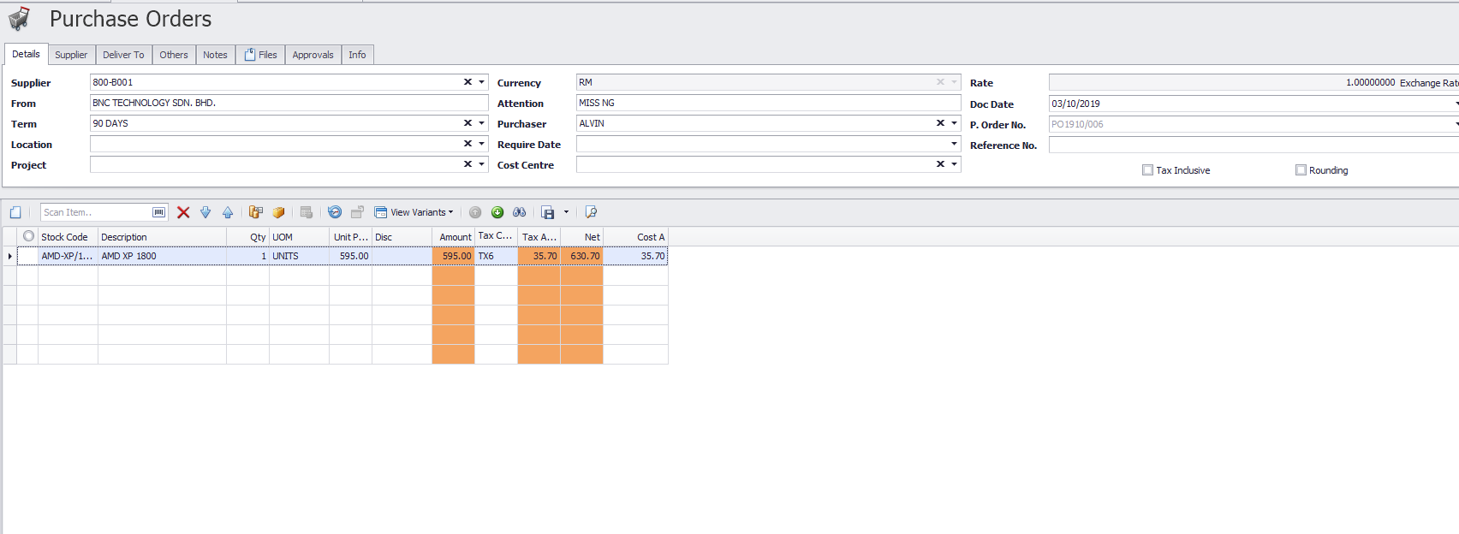

- When we transfer to Purchase invoice, it will post to the landing cost( SST Amount)
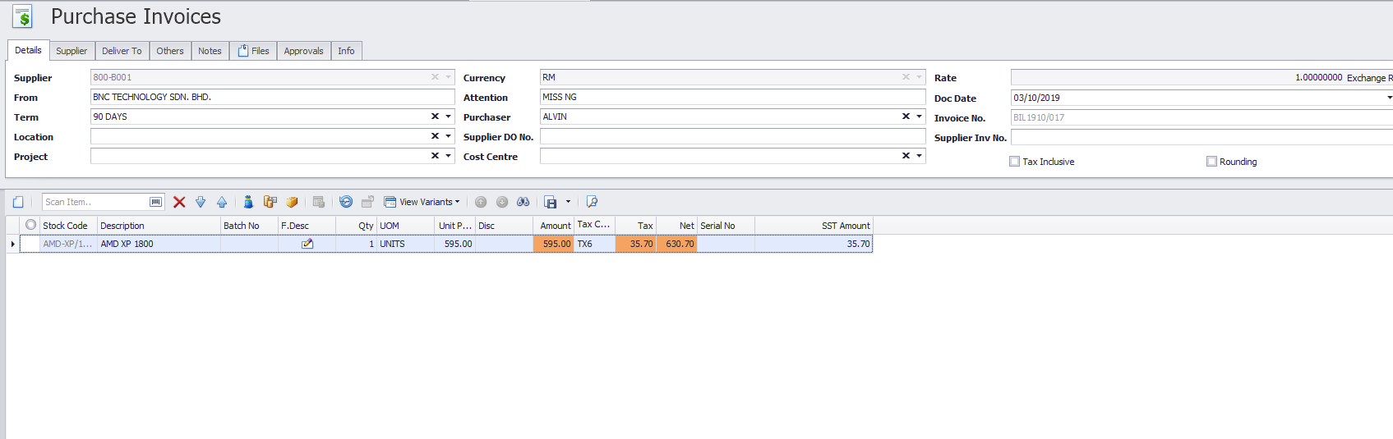

So the tax amount now will post to the landing cost. Thank you.

