To clear AR zero matching amount
- The script to filter out all the ARMatching is zero amount. This is one of the reasons that showing the error message “Sequence is contain More than 1 element”.

- Other than this, If you happen to find that for those transactions with no outstanding but still showing in Customer Knock Off, it is having the same issue.
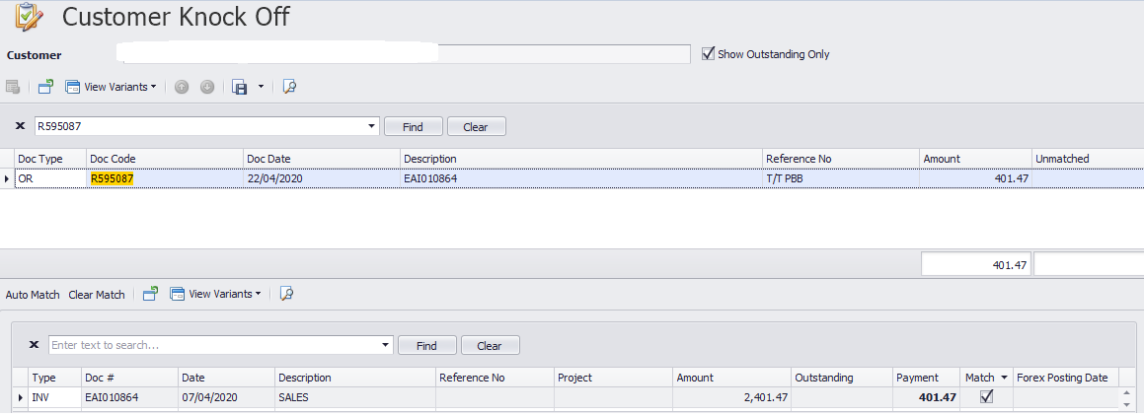

- Using Below script to filter out all the transactions that having matching with zero amount.

/*filter all AR zero matching amount */
select*from armatched where amount = '0' and ARAmountLocal='0' and PayForAmountLocal='0'
select artype,ARTranId,arcode,payfortype,payforid,payforcode, glaccountid, amount, ARAmountLocal, PayForAmountLocal
from armatched where amount = '0' and ARAmountLocal='0' and PayForAmountLocal='0'

/*filter all AP zero matching amount */
select* from apmatched where amount = '0' and ApAmountLocal='0' and PayForAmountLocal='0'
select aptype,ApTranId,apcode,payfortype,payforid,payforcode, glaccountid, amount, ApAmountLocal, PayForAmountLocal
from apmatched where amount = '0' and ApAmountLocal='0' and PayForAmountLocal='0'

Here is the example, you will find out all the transcations that are with zero amount in matching.
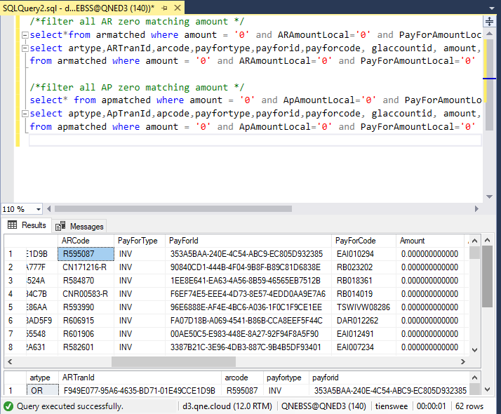

- After filtered out all the transactions that is zero matching amount, delete by running below script.

/*filter all AR zero matching amount */
delete from armatched where amount = '0' and ARAmountLocal='0' and PayForAmountLocal='0'
select artype,ARTranId,arcode,payfortype,payforid,payforcode, glaccountid, amount, ARAmountLocal, PayForAmountLocal
from armatched where amount = '0' and ARAmountLocal='0' and PayForAmountLocal='0'

/*filter all AP zero matching amount */
delete from apmatched where amount = '0' and ApAmountLocal='0' and PayForAmountLocal='0'
select aptype,ApTranId,apcode,payfortype,payforid,payforcode, glaccountid, amount, ApAmountLocal, PayForAmountLocal
from apmatched where amount = '0' and ApAmountLocal='0' and PayForAmountLocal='0'
- Then the problem will be gone, you may check again by using the script in step 3.
Thank you.

