How to Display Supplier Invoice No. & Reference No. in Payment Voucher
To display this two column into Payment Voucher.
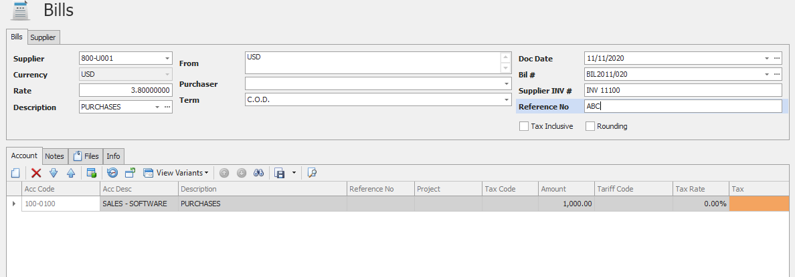
- Go to Payment Voucher, right click on top on the column and select Column chooser.
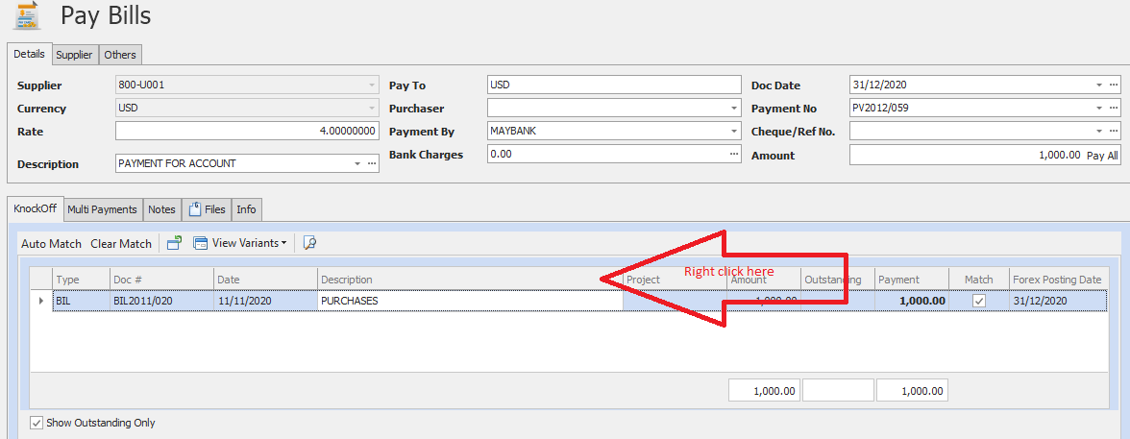

- Select Column Chooser.
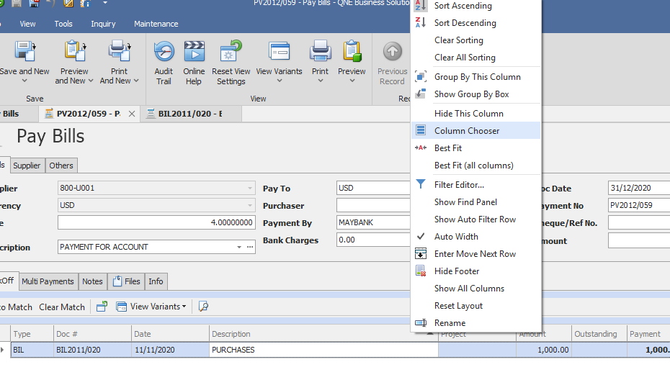

- Look for the column Reference No & Ref 2 and drag it out.
Reference No = Supplier Invoice No.
Ref 2 = Reference No.
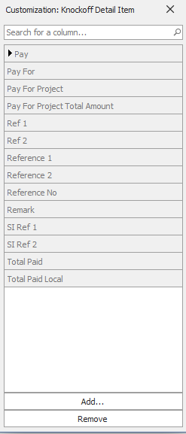

- So it will be like this. Now it already show here.
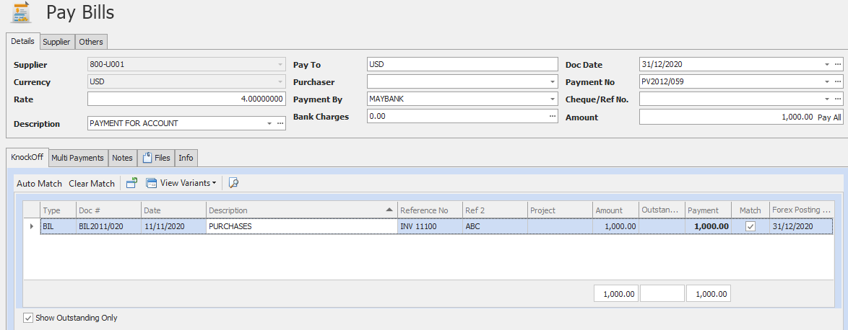
- Next, how we going to put it into the report format.
Go to Task > Design
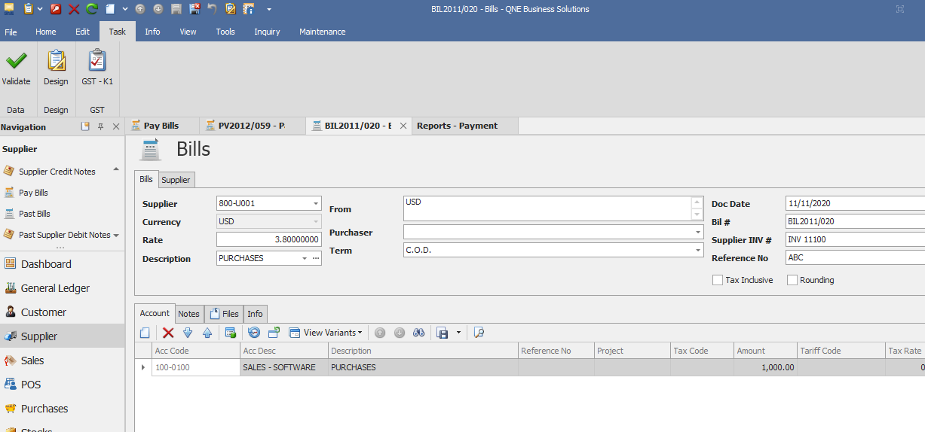

- Select the format that you want to edit and click on Amend or double click on the format.
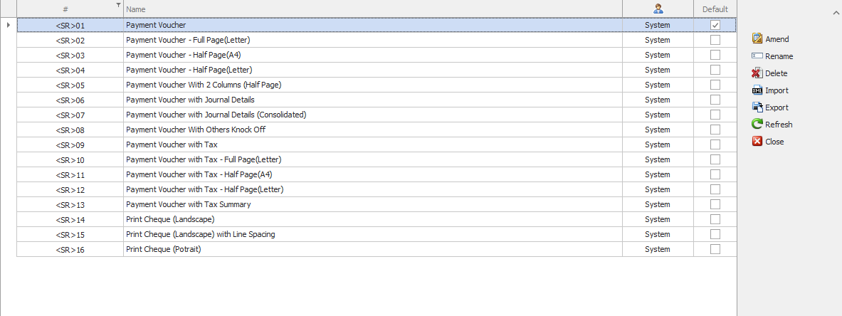
- Then look for the detail of the format. Here is the row that you add in the reference no. and ref 2.
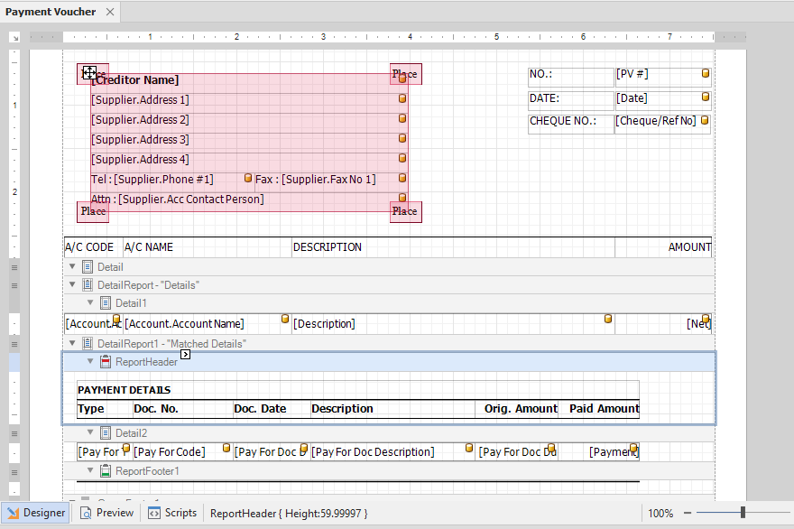

- If you want to show Supplier Invoice No in the Doc. No, you just go to the panel, look for Pay for Reference. It’s under Payment Voucher> Matched Details> Pay for Reference.

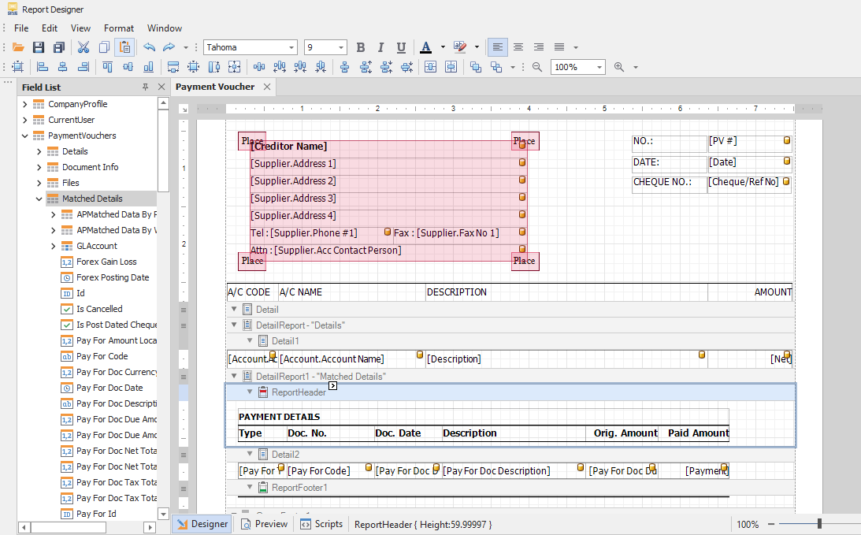

Here will be the columns, just drag it out to the box. For your information, Pay For Ref 2 = Reference No. and Pay for Reference = Supplier invoice no.
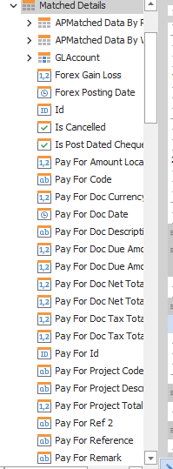

- So here we go to replace Pay for Code to Pay for Reference.
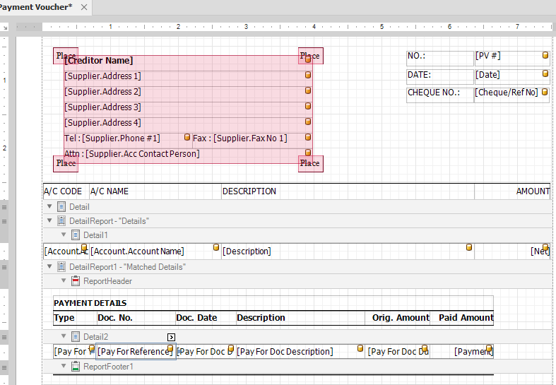

- Click on preview, so now it’s successfully replaced by Supplier invoice no. instead of bill number.
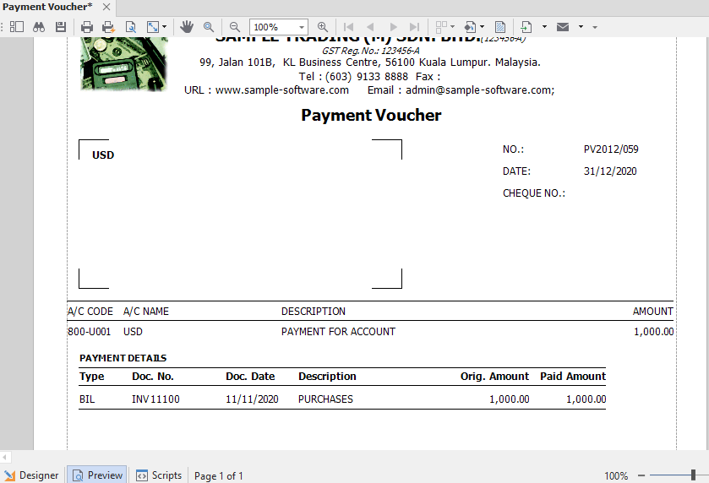
- If you want to have Reference no. in bill to show over here, you just drag Pay For Ref 2 into this column.

- If you want to have both, just create a new column beside and put in Pay For Ref 2.
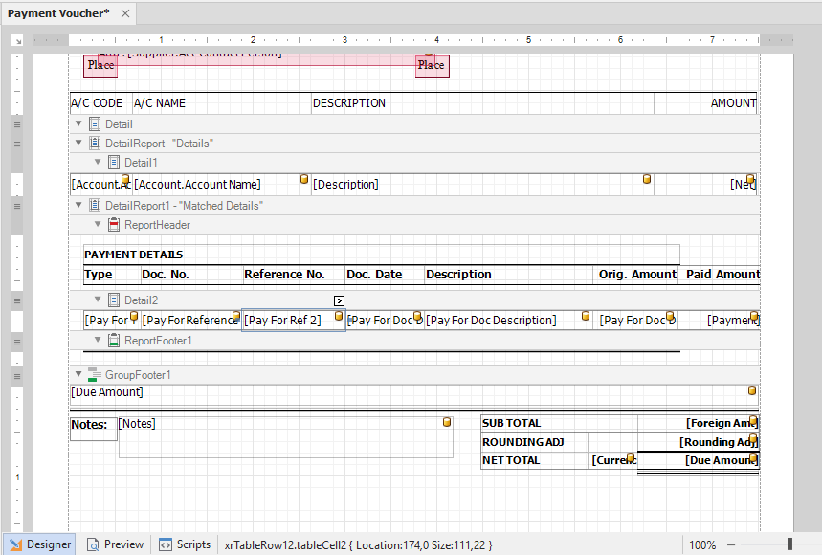
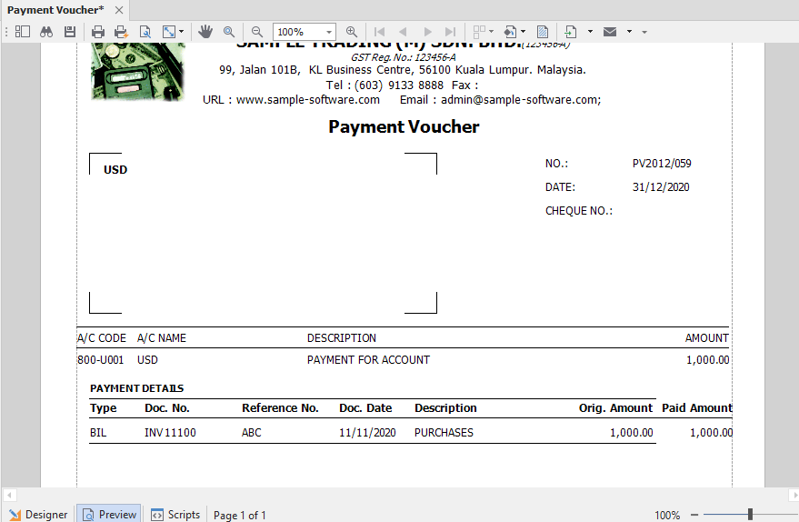
When it’s all set, just click on save, and close the report designer. Go back to the PV and click on refresh, your new format will be there and you may set it to default as well so that don’t need to select it all the time.
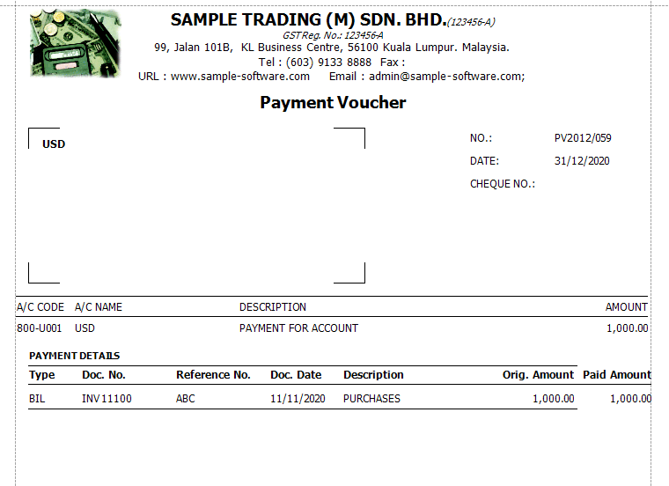

Thank you.

