How to calculate EPF in BONUS if Employee's wages less than 5k but bonus & wages more than 5k?
- Create an employee basic salary as RM 2,800
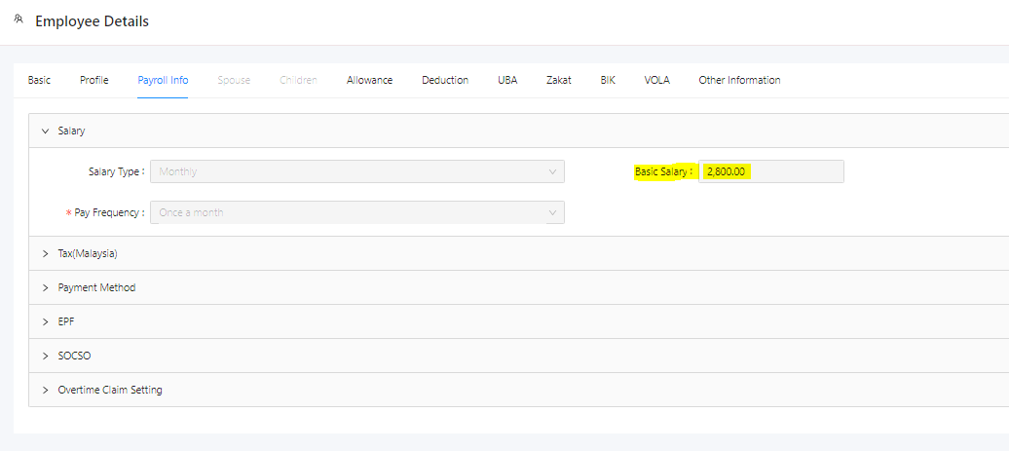

- Set EPF group as Statutory which is 11%
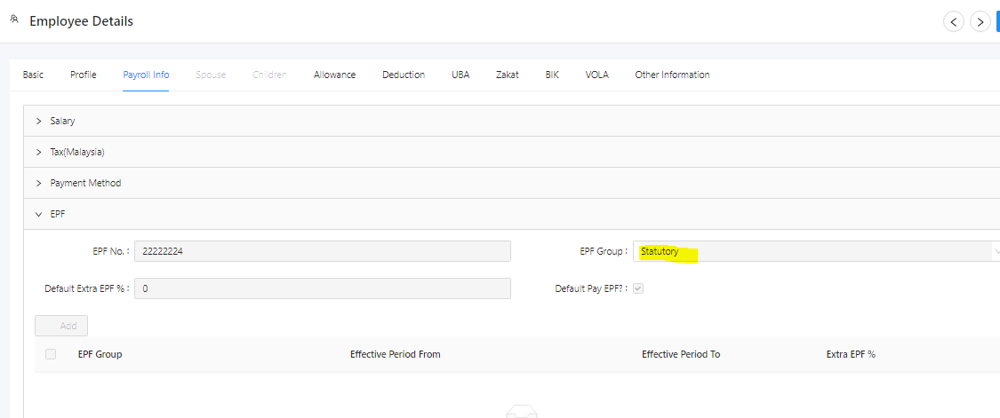

- Generate 2nd half payroll
Basic RM 2800 which is based on 'er 13% 'ee 11%
—> Refer to the EPF Table range (From 2,800.01 to 2,820.00) Employer 364.00 Employee 308.00

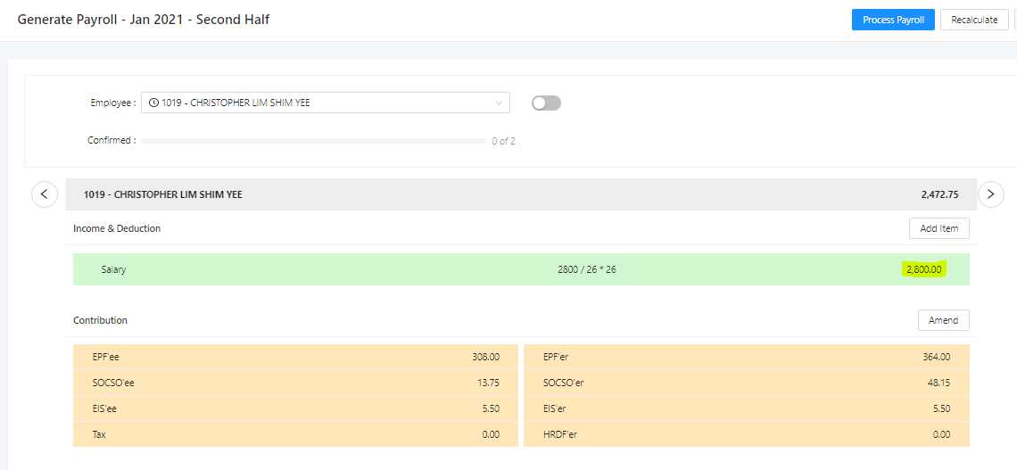
- After this, complete 2nd half payroll process
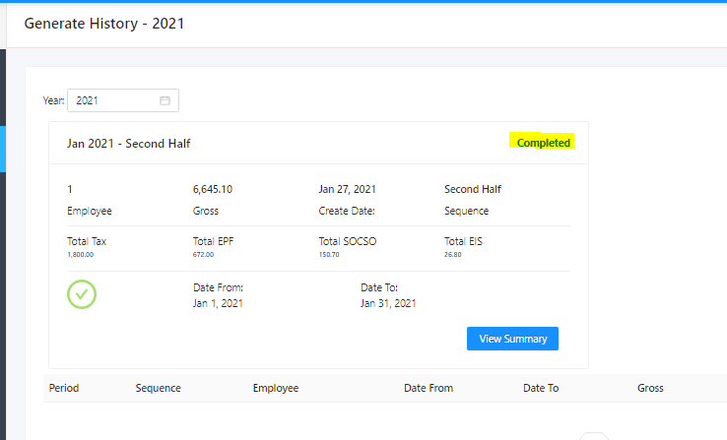
- Generate bonus, update sequence as BONUS then add it
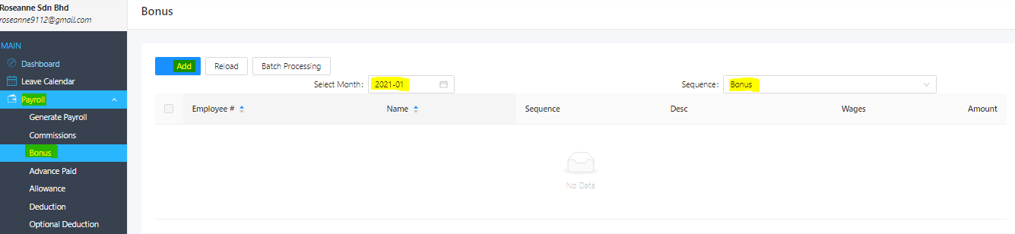
- Update the employee and bonus amount as RM 5,210
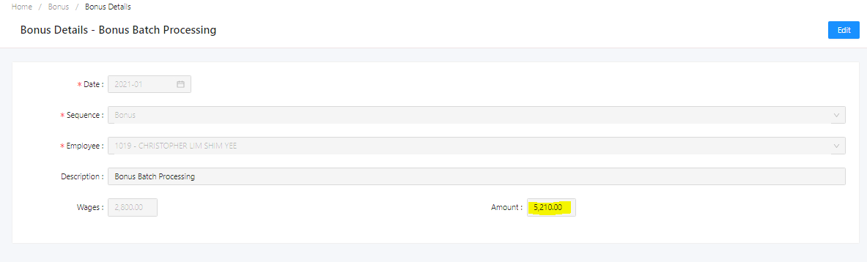
- Go to Generate Payroll for BONUS.
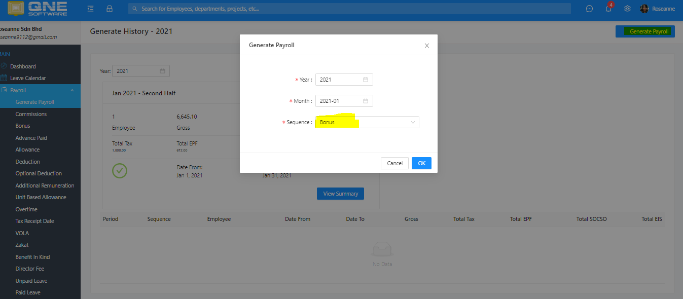

- Notice that the EPF’er is showing as RM 689

Try to calculate (RM 689 / RM 5,210) X 100 = 13%
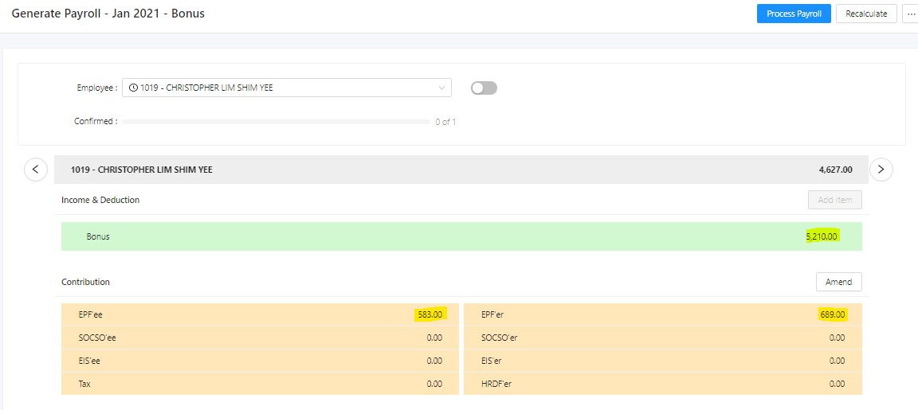
- According to the EPF table as below, those employee’s salary is less than RM 5,000 but bonus time if the wages and bonus is more than RM5,000, the employer side should contribute as 13%
https://www.kwsp.gov.my/documents/20126/927226/BI-Jadual+Ketiga+.pdf

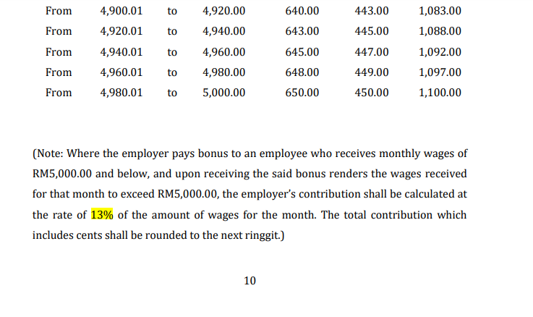

Computation:-
Note: When received a bonus of RM 5,210, we should maintain to calculate the EPF base on 13% because total wage RM2,800 + RM 5,210 is more than RM5,000
If basic wages more than RM 5,000 is computing with 12%

Hence, Bonus EPF calculation will be (RM 2800 + RM 5,210) = RM 8,010

RM 8,010 will fall on range From 8,000.01 to 8,100.00,
If you refer to the table, it is referring as 12%

So, we manual calculate but base on RM 8,100 [Calculation based on Contribution Rate (Third Schedule)]
instead of RM8,010 [Calculation based on exact percentage]

RM 8100 x 13% = RM 1,053.
Bonus EPF for Employer —> RM 1053-RM364 = RM 689 [RM364 paid in 2nd Half]
Bonus EPF for Employee ---> RM 891 - RM 308 [RM308 paid in 2nd Half] = RM 583

